Using String Patterns and Range

Retrieving rows from a Table

* Using String Patterns, Ranges, and Sets
  + 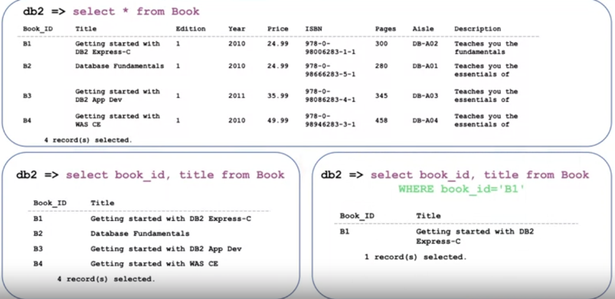[1][2]
  + Retrieving rows – using a String Pattern
    - WHERE requires a predicate
    - A predicate is an expression that evaluate to True, or Unknown
    - Use the LIKE predicate with string patterns for the search
    - Example: WHERE <columnname>LIKE<string pattern>
      * WHERE firstname LIKE R%
      * 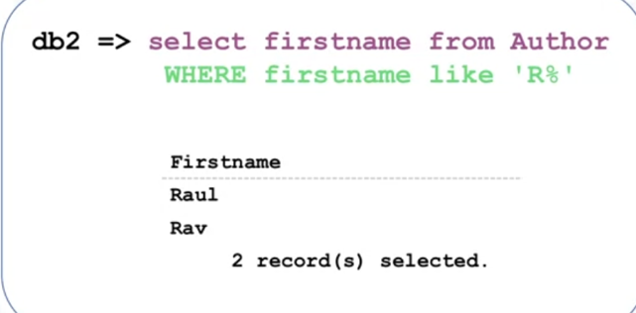
      * 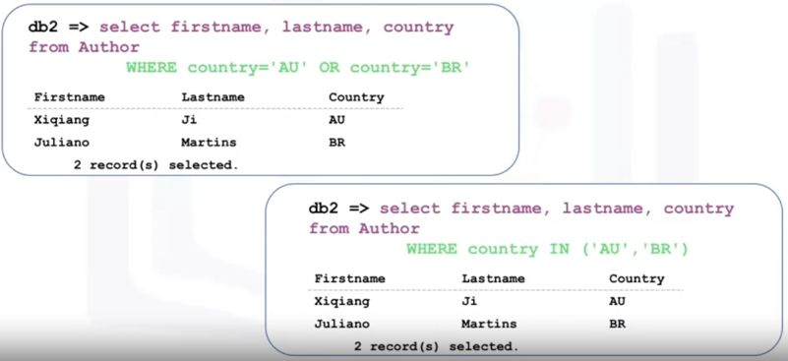
* Sorting Result Sets
  + 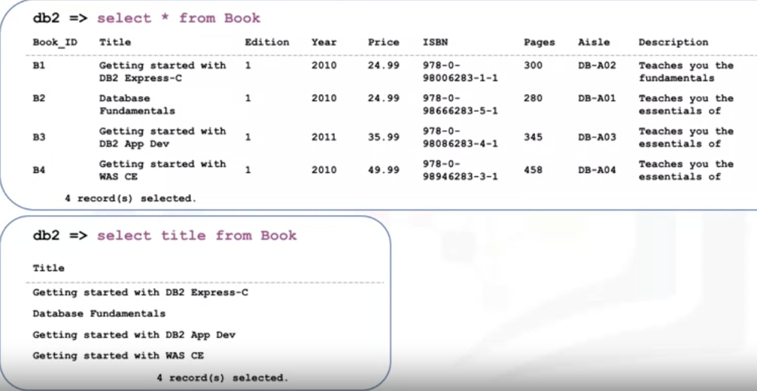
  + Using the ORDER BY clause
    - 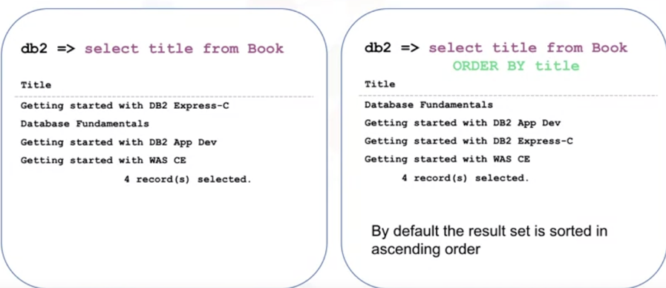
  + Using BY clause – Descending order
    - 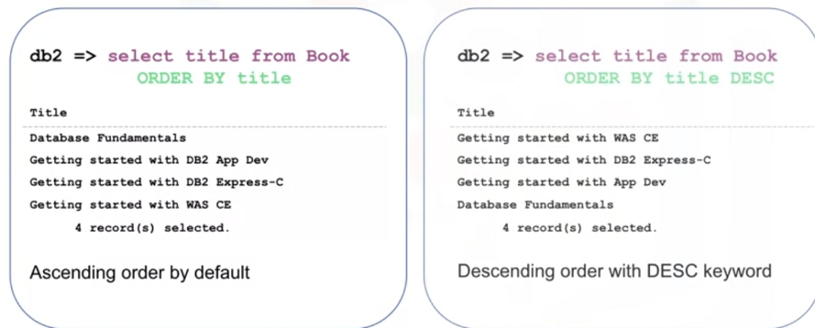
  + Specifying Column Sequence Number
    - 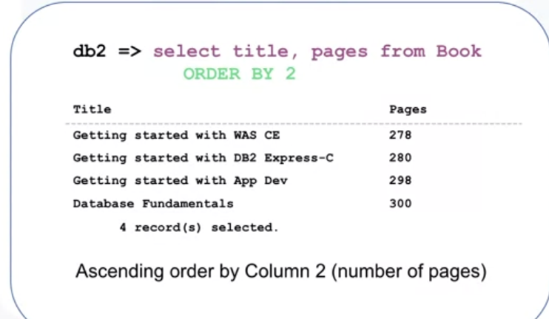
* Grouping Result Sets
  + Describe how to further restrict a result set
  + Eliminate duplicates from a result set
    - Eliminating Duplicates – DISTINCT clause
      * + 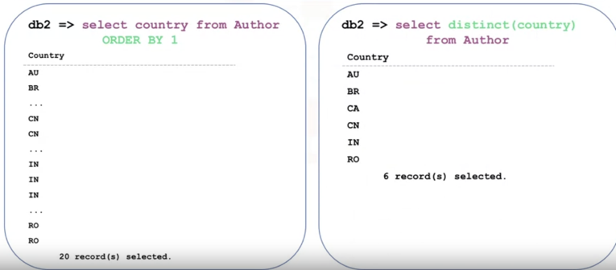
      * GROUP BY clause
        + 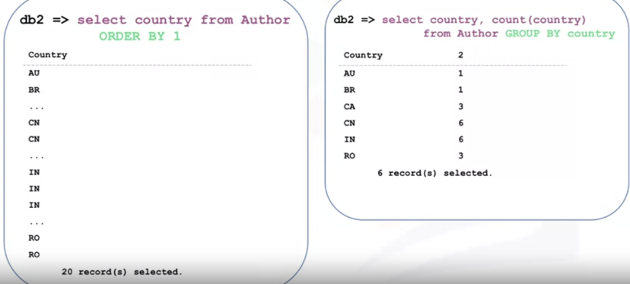
      * Restricting the Result Set – HAVING clause
        + 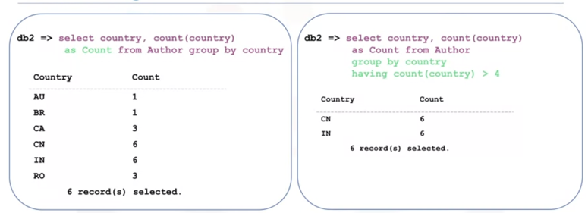
    - you use the HAVING keyword right after GROUP BY to query the database based on a specified condition.
    - The HAVING keyword was introduced because the WHERE clause fails when used with aggregate functions
* Quiz:
  + You want to retrieve a list of employees in alphabetical order of Lastname from the Employees table. Which SQL statement should you use? (ANS. SELECT * FROM Employees ORDER BY Lastname;)
  + You want to retrieve a list of authors from Australia, Canada, and India from the table Authors. Which SQL statement is correct? (ANS. SELECT * FROM Author WHERE Country IN (‘Australia’, 'Canada', 'India');
  + You want to retrieve a list of books priced above $10 and below $25 from the table Book. What are the two ways you can specify the range? (ANS. SELECT Title, Price FROM Book WHERE Price >= 10 and Price <= 25; SELECT Title, Price FROM Book WHERE Price BETWEEN 10 and 25;
  + You want to retrieve Salary information for an employee called Ed from the Employee table. You write the following statement:

SELECT Firstname, Lastname, Salary FROM Employees

You see all the employees listed, and it’s hard to find Ed’s information. Which clause should you add to reduce the number of rows returned? (ANS. WHERE Firstname = ‘Ed’;)

Functions, Multiple Tables, and Sun-queries

Built-in Database Functions

* Most databases come with built-in SQL functions
* Built-in functions can be included as part of SQL statements
* Database functions can significantly reduce the amount of data that needs to be retrieved.
* Can speed up data processing
* Example:
  + 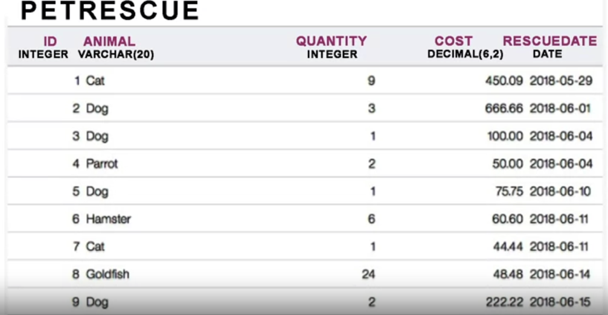
  + Aggregate or Column Functions
    - *INPUT:* Collection of values (e.g. entire column)
    - *Output:* Single value
    - *SUM()* function: Add up all the value in a column : SUM(COLUMN_NAME)
      * 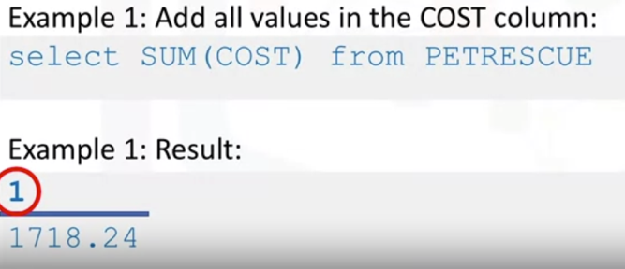
      * 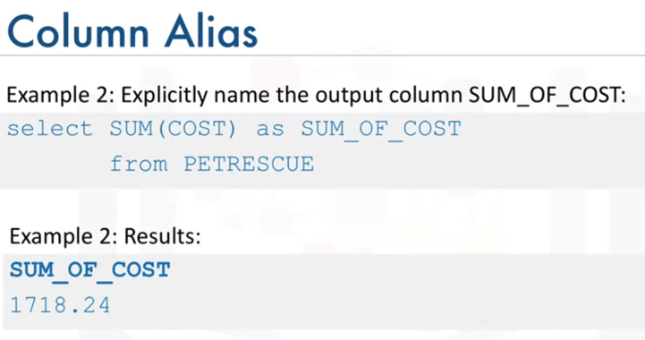
    - *MIN() // MAX() function:* return the MINIMUM value
      * 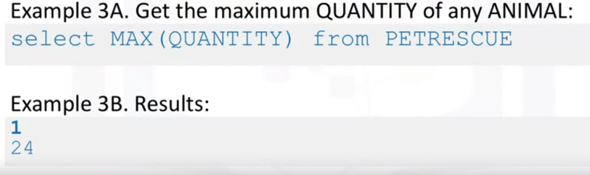
      * 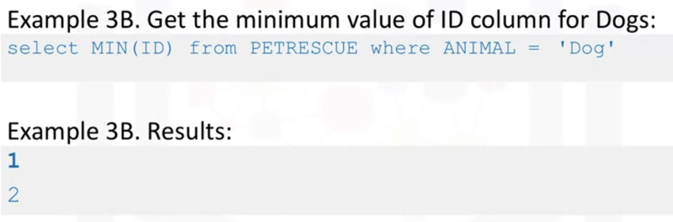
    - *AVG() function:* Return the average value
      * 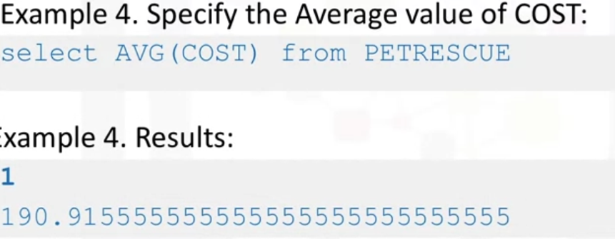
      * Mathematical operations can be performed between columns
        + 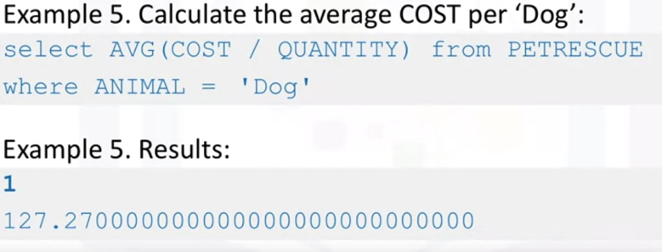
  + SCALER and STRING FUNCTIONS
    - SCALER: Perform operations on every input value
      * *ROUND() :* To round up or down every value in the cost column to the nearest integer.
        + 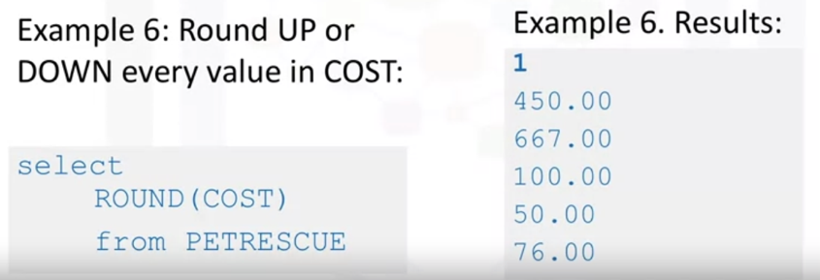
      * *UCAS //:* To retrieve animal values in uppercase
        + 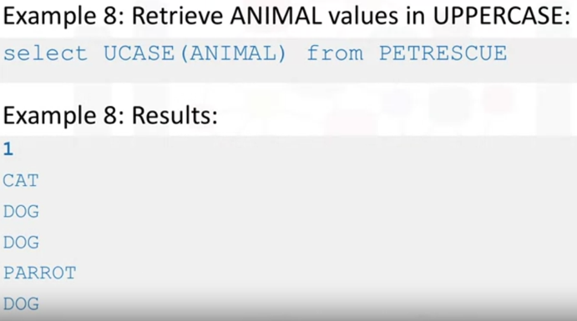
* *LCASEE :*WHERE Use the function in a WHERE clause:
  + 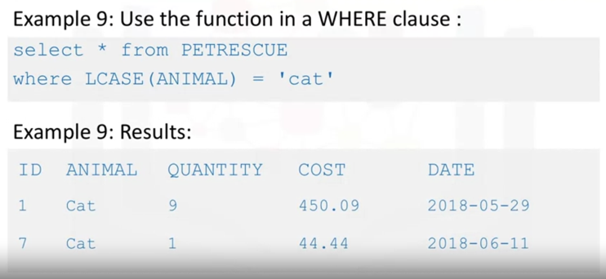
  + 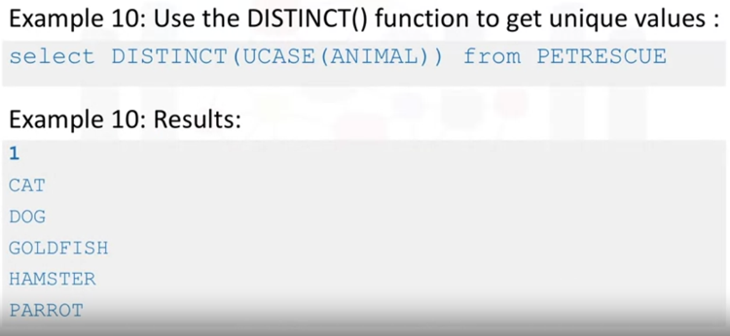
    - STRING :to retrieve the length of each value in animal column
* Date, Time Functions
  + Most databases contain special datatypes for dates and times
    - *DATE*  YYYYMMDD
    - *TIME:* HHMMSS
    - *TIMESTAMP:* YYYYXXDDHHMMSSZZZZZZ
    - *Date/Time functions:*
      * 
      * 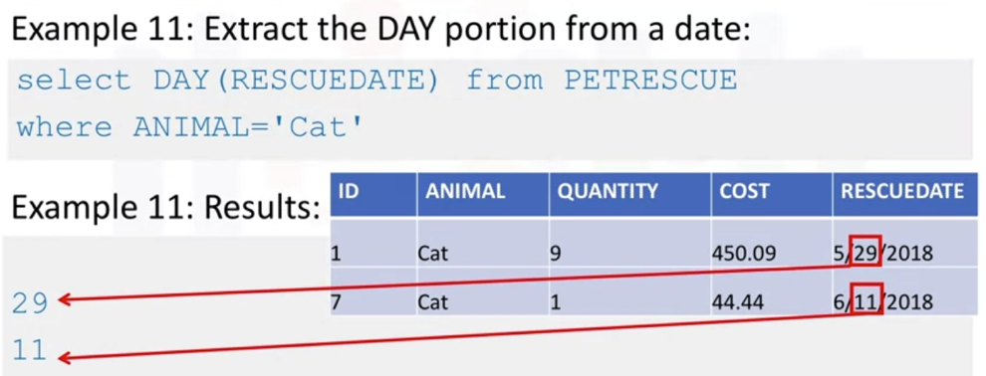
      * 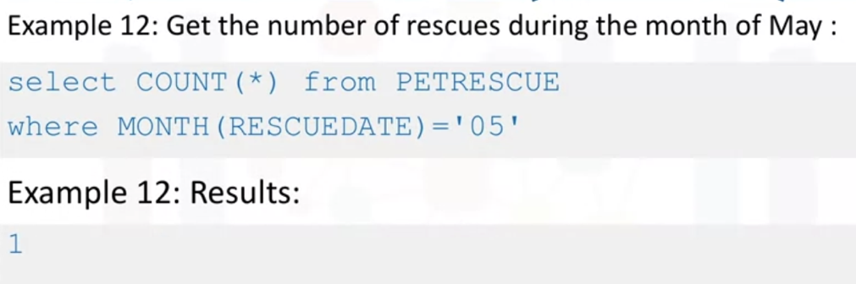
    - *Date or Time Arithmetic:*
      * 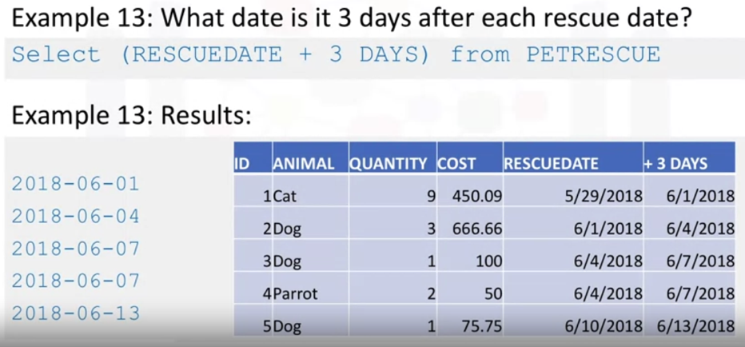
    - *Date or Time Arithmetic: Special Registers:*
      * 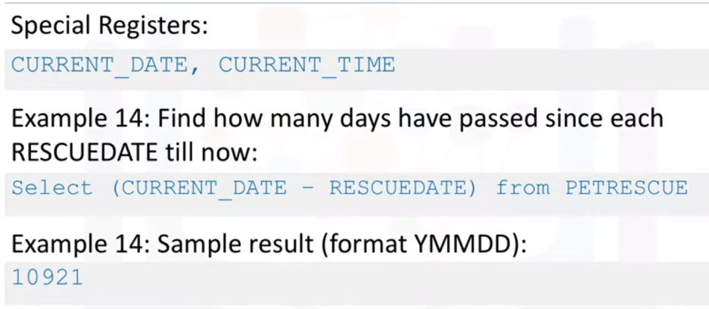

Sub-Queries and Nested Selects

* Sub-query: A query inside another query
  + 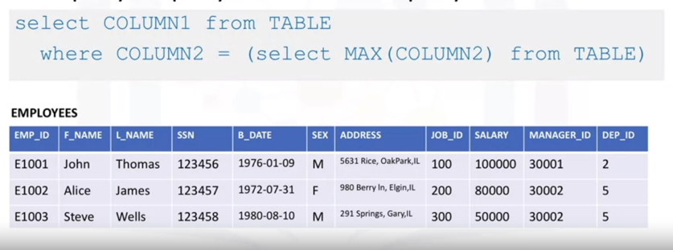
  + 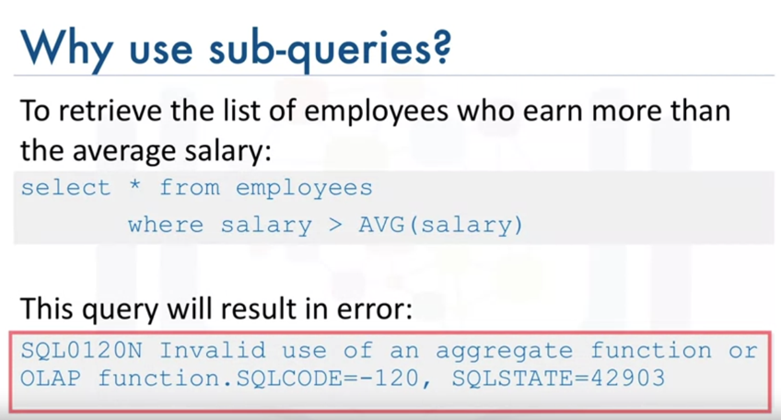
  + Sub-queries to evaluate Aggregate functions
    - Cannot evaluate Aggregate functions like AVG() in the WHERE clause-
    - Therefore, use a sub-Select expression:
      * 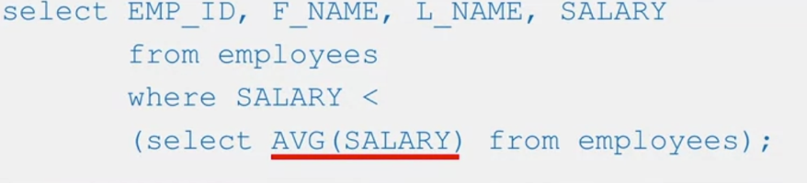
  + Sub-queries in list of columns
    - Substitute column name with a sun-query
    - Called Column Expressions
      * 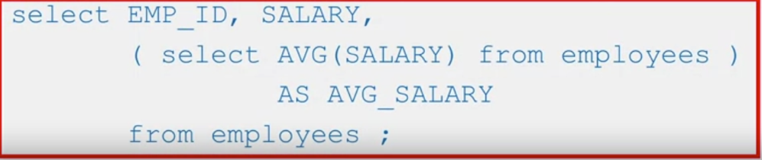
  + Sub-queries in FROM clause
    - Substitute the TABLE name with a sub-query
    - Called Derived Tables or Table Expressions
      * 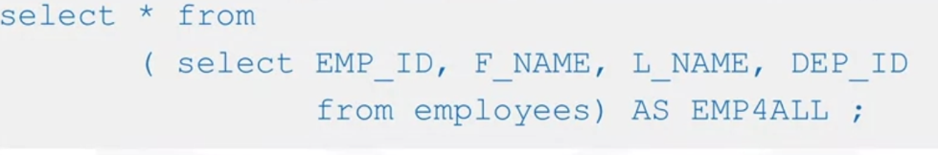

Summary:

* *How sub-queries and nested queries from richer queries*
* *How they overcome limitations of aggregate functions*
* *How to use sub-queries in the:* 
  + *WHERE clause*
  + *List of columns*
  + *FROM clause*

Working with Multiple Tables

Ways to access multiple tables in the same query:

1. Sub-queries
2. Implicit JOIN
3. JOIN operators (INNER JOIN, OUTER JOIN,etc.)

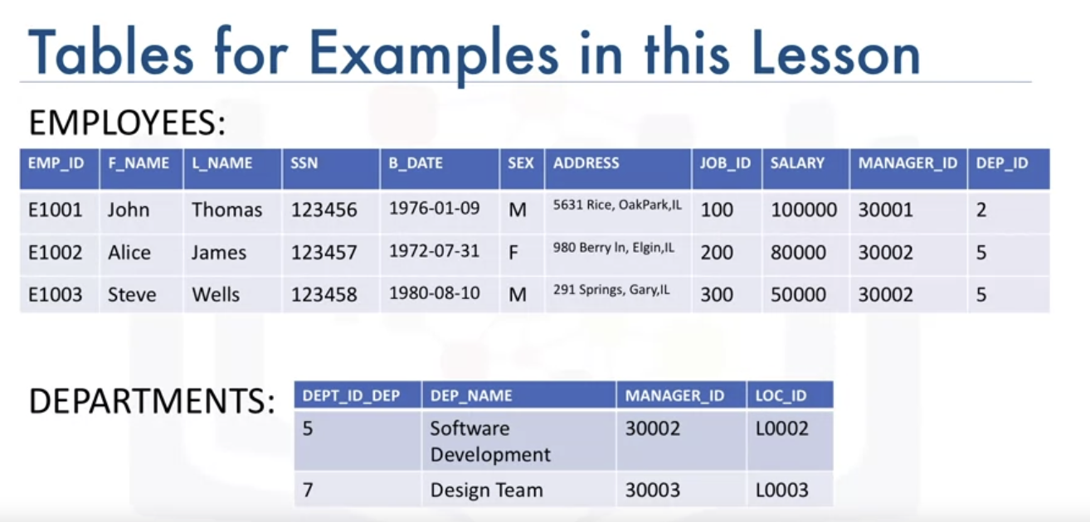

* Accessing Multiple Tables with Sub-queries
  + To retrieve only the employee records that correspond to departments in the DEPARTMENTS table:
    - 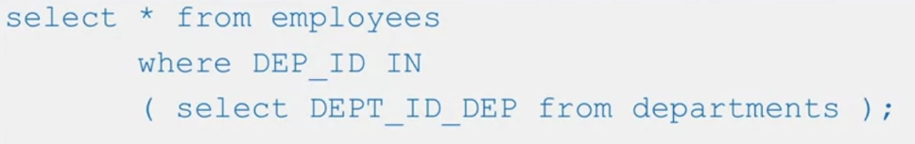
  + To retrieve only the list of employees from a specific location:
    - EMPLOYEES table does not contain location information
    - Need to get location info from DEPARTMENTS table
      * 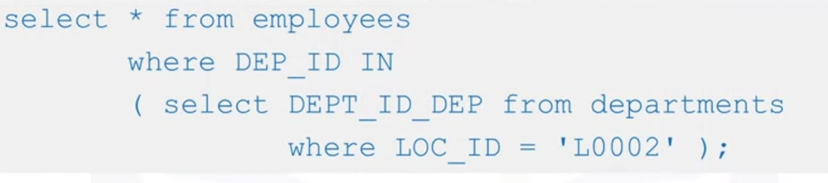
      * 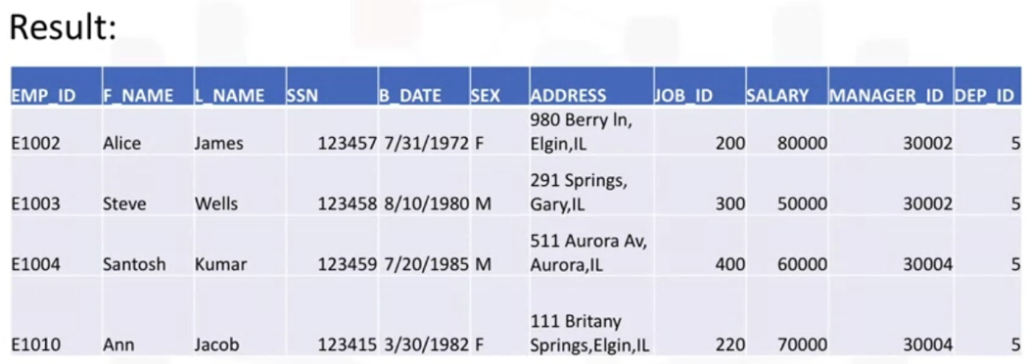
  + To Retrieve the department ID and name for employees who earn more than $70,000
    - 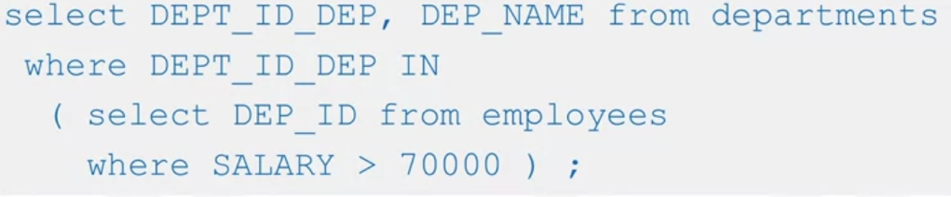
    - 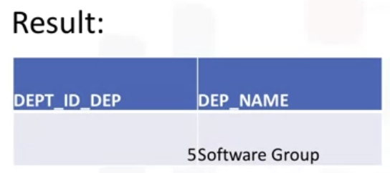
* Accessing multiple tables with Implicit Join
  + Specify 2 tables in the FROM clause:
    - 
      * The result is a full join(or Cartesian join):
        + Every row in the first table is joined with every row in the second table
        + The result set will have more rows than in both tables.
  + Use additional operands to limit the result set:
    - 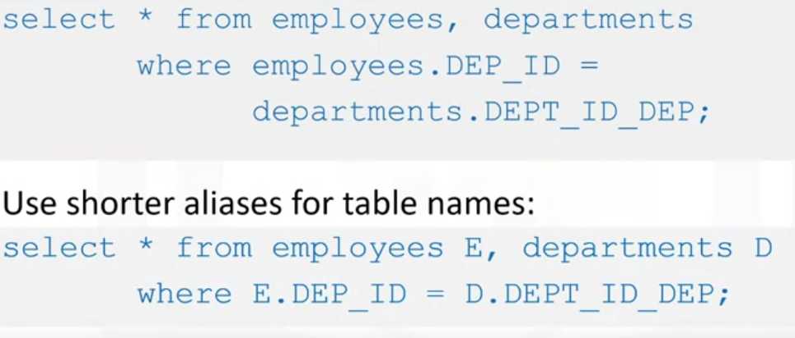[3]
  + Query:
    - 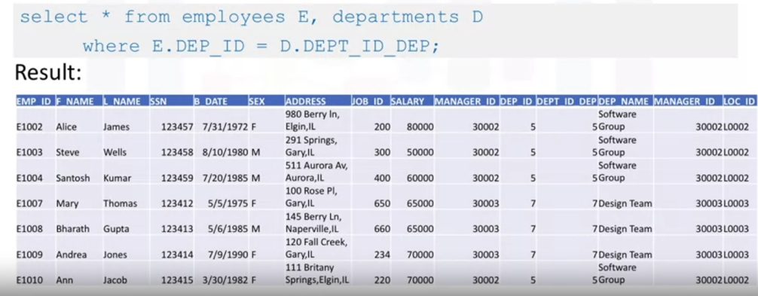
  + To see the department name for each employee
    - 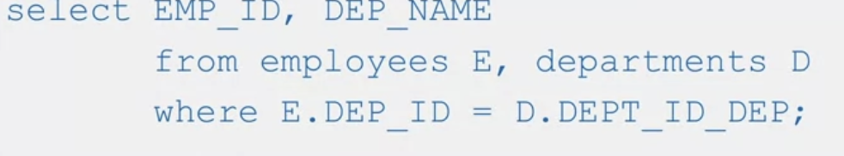
    - 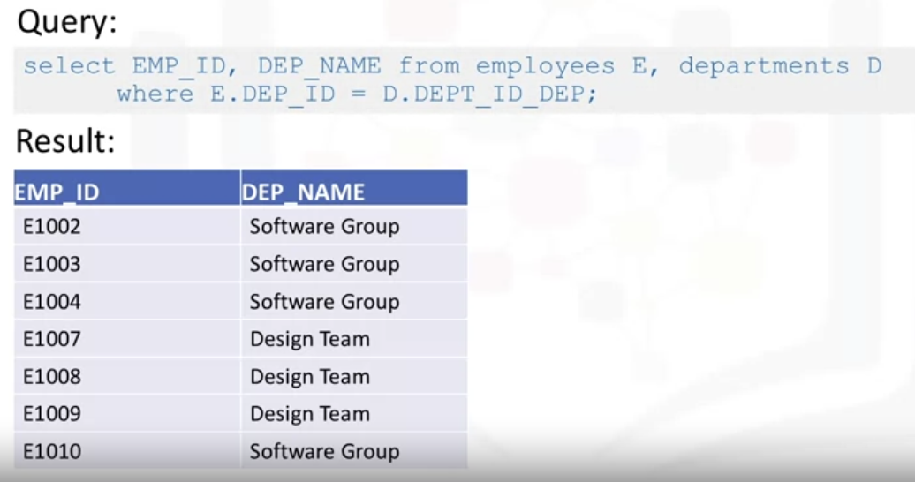
  + Column names in the select clause can be pre-fixed by aliases:
    - 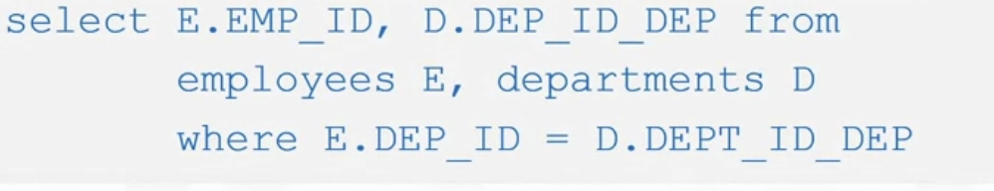
    - 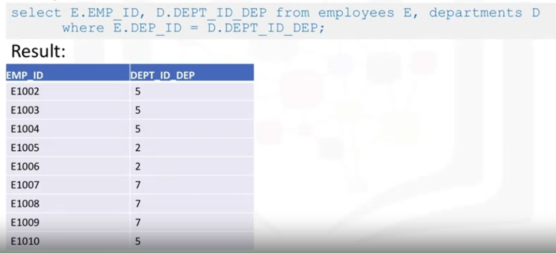

1. If only remember the author’s last name starts with the letter B, which string pattern can use WHERE Firstname = ‘Ed’;
2. Retrieving rows from a table
3. E: Employee; D: Department